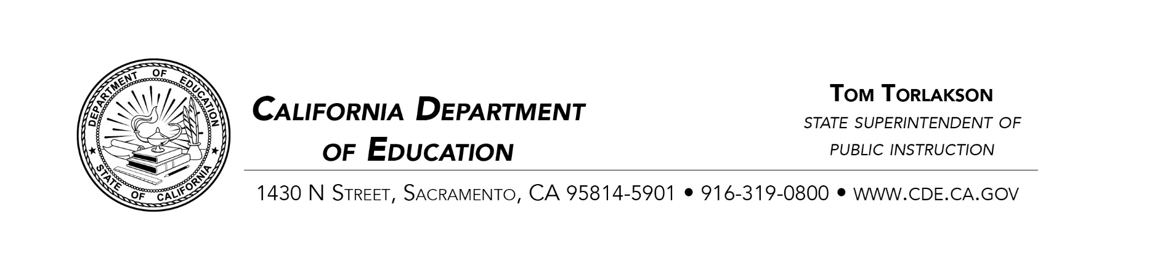

Sent via First Class Mail and E-mail to:
fjferrer408@gmail.com
mgil@rsed.org
jcolon@rsed.org

May 21, 2018
Dr. Frederick Ferrer, President of the Rocketship Education Board
Marie Gil, Regional Director
Jason Colón, Founding Principal
Rocketship Futuro Academy
2351 Olivera Road
Concord, CA 94520
Dear Dr. Ferrer, Director Gil, and Principal Colón:
Subject: Letter of Concern Regarding the English Learner Focused Site Visit Conducted for Rocketship Futuro Academy on March 15, 2018, and Requests for Plans to Address Non-Compliance Concerns, Additional Documentation, and Assurances
Thank you for the opportunity to visit Rocketship Futuro Academy (RFA). The California Department of Education (CDE) appreciates the tremendous amount of work you orchestrated before and during this site visit focused on RFA’s program for English learners (ELs).
The following is a summary of the areas of non-compliance concerns, which were discussed at the exit meeting on March 15, 2018.
Summary of Non-Compliance Concerns:
- Criteria
- The CDE and State Board of Education (SBE) recognize that both designated and integrated English Language Development (ELD) is an integral part of a comprehensive program for every EL student to meet the linguistic and academic goals at their grade level.
- On September 18, 2015, the SBE and CDE provided resources in a letter to all county and district superintendents and charter school administrators regarding designated and integrated ELD. The letter can be found on the CDE Web page at http://www.cde.ca.gov/nr/el/le/yr15ltr0918.asp.
- On August 30, 2016, the CDE issued a letter to all county and district superintendents and charter school administrators regarding their legal obligations to ELs. The letter clearly states that charter schools have a dual obligation, as do all local educational agencies, to provide a program for EL students designed to overcome language barriers and provide access to the core curriculum. The letter can be found on the CDE Web page at http://www.cde.ca.gov/sp/el/er/charterschoolelltr.asp.
- Observation
- The CDE has determined through classroom observations and interviews with the Rocketship leadership, that ELs are not receiving access to appropriate ELD instruction, specifically designated ELD instruction. The CDE further determined at the site visit that RFA was not implementing integrated ELD instruction, designated ELD instruction, Guided Language Acquisition Design and Specifically Designed Academic Instruction in English as described on pp. 84–93 in the RFA charter petition.
- Corrective Action–Action Plan to be submitted to the California Department of Education for Review:
  - The Rocketship Public Schools Board must provide documentation to demonstrate the appropriate levels of support, and ELD instruction for EL pupils enrolled at RFA including, but not limited to, what is expressly stated in the RFA petition on pp. 84–93. This plan must be provided to SBEOVERSIGHT@cde.ca.gov within 15 calendar days from the date of this letter.
- Non-Compliance Concern–English Learner Advisory Committee
  - The CDE has determined through interviews with the Rocketship leadership and through artifact reviews that RFA has not provided evidence of an established English Learner Advisory Committee (ELAC) for parents or other community members who want to advocate for English Learners as described on p. 94 of the RFA charter petition.
- Corrective Action–Action Plan to be submitted to the California Department of Education for Review:
  - The Rocketship Public Schools Board must provide documentation to demonstrate that RFA has a properly established an ELAC and that the ELAC meets regularly to support the EL program at RFA as explicitly stated on p. 94 of the RFA charter petition. This plan must be provided to SBEOVERSIGHT@cde.ca.gov within 15 calendar days from the date of this letter.
The CDE notes that the concerns regarding RFA’s EL instructional program presented in this letter were also concerns noted in the CDE letter dated October 16, 2017, Summary of English Learner Focused Site Visit Conducted March 8, 2017. Additionally, the CDE notes that the State Superintendent of Public Instruction specifically requested a yearly EL site visit in addition to the annual site visit as a condition of RFA’s charter authorization. Therefore, if RFA is unable to address these concerns or otherwise provide the corrective action for each of these concerns raised by the CDE by the due date listed in this letter, the CDE may recommend that the SBE take further action regarding RFA. This action may include a Notice of Violation issued to RFA. A Notice of Violation is considered to be the first notification in the process of revocation pursuant to EC Section 47607(d).
If you have any questions regarding this letter, please contact Chaddrick Owes, Education Programs Consultant, Charter Schools Division, by phone at 916-445 6761 or by e-mail at cowes@cde.ca.gov.
Sincerely,
Lisa F. Constancio, Director
Charter Schools Division
LFC:co
cc: Karen Stapf Walters, Executive Director, California State Board of Education
Nick Schweizer, Deputy Superintendent, Systems Support Branch, California Department of Education

